Chapter 8, Problem 68.

For the step function v_{s} = u(t), use PSpice to find the response v(t) for 0 < t < 6 s in the circuit of Fig. 8.113.

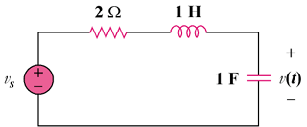

Figure 8.113
For Prob. 8.68.

